# Assignment 3: Exploring Memory Hierarchy Design in gem5

## Part 1: Understanding Memory Hierarchy

To provide best performance, high-performance computing systems mostly depend on effective memory management and use. Achieving this depends critically on memory hierarchy design, which arranges several memory technologies into a tiered structure each providing a trade-off between speed, capacity, and cost. This architecture guarantees that the computational requirements of contemporary applications are satisfied by allowing systems to balance performance with efficiency. We explore the relevance of memory hierarchy design below with an eye toward memory technologies, advanced cache optimization, virtual memory, and cross-cutting problems.

Memory Technologies - Modern memory hierarchies are constructed from a range of memory technologies, each having special qualities that affect their hierarchy of placement. At the top of the hierarchy, Static Random Access Memory (SRAM) is used for cache memory because of its great speed and low latency. Maintaining the high throughput demanded in modern CPUs depends on near-instinctual access to frequently utilized data, which SRAM offers. Its poor density and great cost make it unworkable for use as primary memory or storage, however. Conversely, the foundation of main memory is dynamic random access memory (DRAM). Although slower and less costly than SRAM, DRAM has far more store capacity, which qualifies for most applications' necessary big datasets. But DRAM's need on regular refresh processes adds delay that could compromise performance, especially in memory-intensive tasks. Newer technologies such 3D-stacked memory and non-volatile memory (NVM) are starting to show up beyond SRAM and DRAM. Though at a greater latency than conventional DRAM, NVM—including NAND flash and Phase Change Memory (PCM—offers low power consumption and permanent storage. High Bandwidth Memory (HBM) and other 3D-stacked memory technologies integrate memory closer to the CPU, hence lowering latency and increasing bandwidth. These developments are changing memory hierarchies by adding fresh layers that close the gap between conventional DRAM and persistent storage, therefore improving general system performance.

Advanced Cache Optimization - Acting as fast buffers between the CPU and main memory, caches are absolutely essential in memory hierarchies. Advanced methods of cache optimization seek to reduce cache misses, therefore greatly compromising speed. To meet these demands, methods include victim caches, cache splitting, and prefetching have been created. Prefetching is a proactive technique wherein data probably to be retrieved soon is brought into the cache ahead of time. Especially in workloads with consistent access patterns, prefetching lowers the possibility of cache misses by predicting future memory accesses. It does, however, bring problems like higher memory traffic and power consumption that need for careful calibration. An auxiliary cache, victim caches hold data expelled from the main cache because of capacity limits. This method reduces the performance penalty related to frequent cache evictions by helping to recover previously expelled material that could be retrieved once more shortly. Victim caches are very successful in reducing conflict misses brought on by low associativity in main caches. Another sophisticated method for maximizing cache usage in multi-core systems is cache partitioning. Cache partitioning guarantees fair access and helps to avoid resource congestion by designating certain areas of the cache to many threads or programs. In shared settings especially, where one process can otherwise control the cache and cause performance deterioration for other processes, this is very crucial.

Virtual Memory and Virtual Machines - A pillar of contemporary computer systems, virtual memory offers a layer of abstraction between physical memory and the operations it powers. Virtual memory lets many programs reside in memory free from interference by separating memory into fixed-sized pages and using page tables for address translation. Through process isolation, this abstraction improves system stability and simplifies programming. Enabled by the Memory Management Unit (MMU), address translating dynamically converts virtual addresses to physical addresses. Although this procedure adds more delay, methods like Translation Lookaside Buffers (TLBs) cache often used address mappings therefore reducing this burden. Maintaining great performance depends on effective TLB design, especially for systems with significant memory footprints. Management of memory under heavy demand depends critically on page replacement algorithms. Least Recently Used (LRU) and variations including Clock and Second-Chance policies seek to remove the least important data from memory, therefore reducing the effect on system performance. Particularly in applications with erratic memory access patterns, the efficiency of these methods directly affects the performance of virtual memory systems. Virtual machines let many operating systems operate simultaneously on the same hardware, hence extending the usefulness of memory hierarchies. In cloud computing and server consolidation—where resources are shared among many users and applications—this feature is very vital. Virtual machines complicate memory hierarchies even more as they need layered page tables to control address translation at many levels. Notwithstanding its complexity, virtualization is a vital technology as it offers improved resource use and isolation, which help to maximize it.

Cross-Cutting Issues - Creating memory hierarchies is negotiating a challenging terrain of trade-offs. Cost is a major consideration as high-performance memory technologies like SRAM and HBM are costly and only useful on the top levels of the hierarchy. Managing cost with performance calls for rigorous evaluation of application needs and workload factors. Another crucial issue is power consumption, especially in mobile devices and data centers where energy efficiency rules. Low-power substitutes were developed in response to memory technologies like DRAM using significant power during refresh cycles. Dynamic voltage and frequency scaling (DVFS) and memory compression are under investigation as means to lower power consumption without compromising performance. Additionally difficult for memory hierarchy design is complexity. Advanced technologies such as cache partitioning and prefetching provide more hardware and software needs, therefore raising the general system complexity. Ensuring fit with current architectures and software stacks adds to this difficulty and calls for thorough testing and validation. Variability in workload further challenges memory hierarchy design. Applications include data-intensive chores like machine learning to compute-intensive duties like scientific simulations. Every workload has different memory access patterns, which calls for different optimizing techniques. High-bandwidth memory, for example, helps compute-intensive workloads; data-intensive workloads need for effective storage and cache systems. Memory hierarchies are being shaped going forward by new trends and technology. Combining DRAM with NVM is becoming popular as hybrid memory systems provide DRAM's performance along with NVM's durability. Silicon photonics and other connectivity technologies are advancing and should help to lower latency and boost bandwidth between memory and CPUs. Concurrent with this development of domain-specific accelerators such as GPUs and TPUs, the need for customized memory hierarchies tuned for certain workloads is resulting.

A basic feature of high-performance computing, memory hierarchy design helps systems to balance cost, capacity, and speed. Modern systems reach the speed needed for demanding workloads by using a wide range of memory technologies, sophisticated cache optimization methods, and virtual memory power leveraging. Still, the difficulties of cost, power consumption, complexity, and task variation highlight how urgently this industry needs ongoing innovation. Memory hierarchies will always be front and foremost in attempts to push the envelope of computing capability as new technologies change the terrain.

## Part 2: Implementing and Analyzing Cache Configurations in gem5

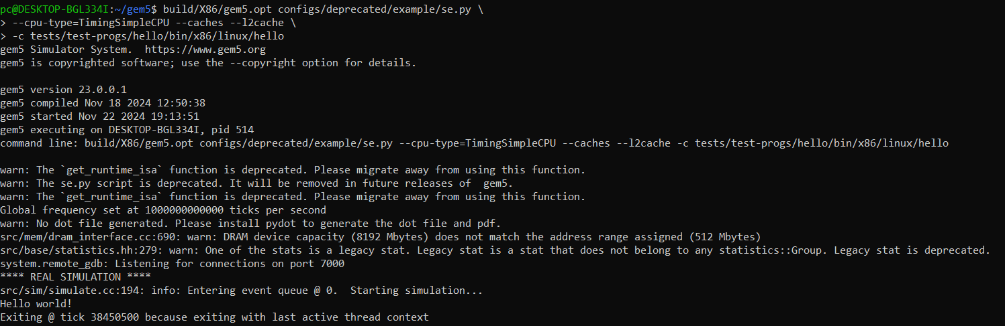

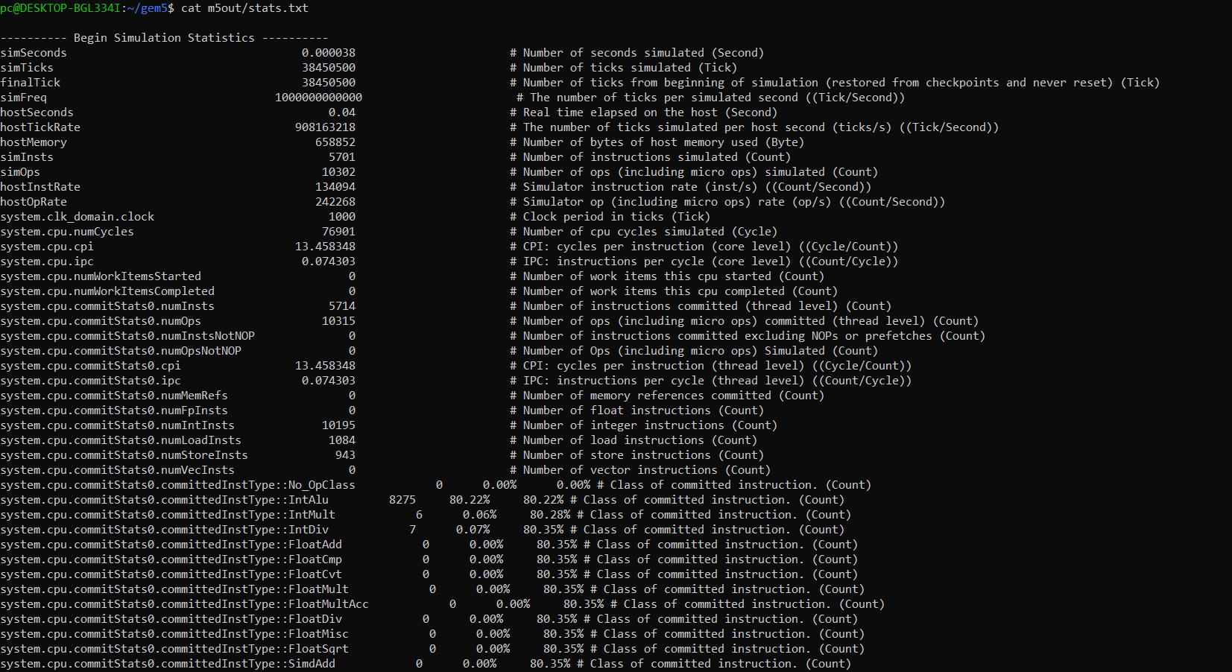

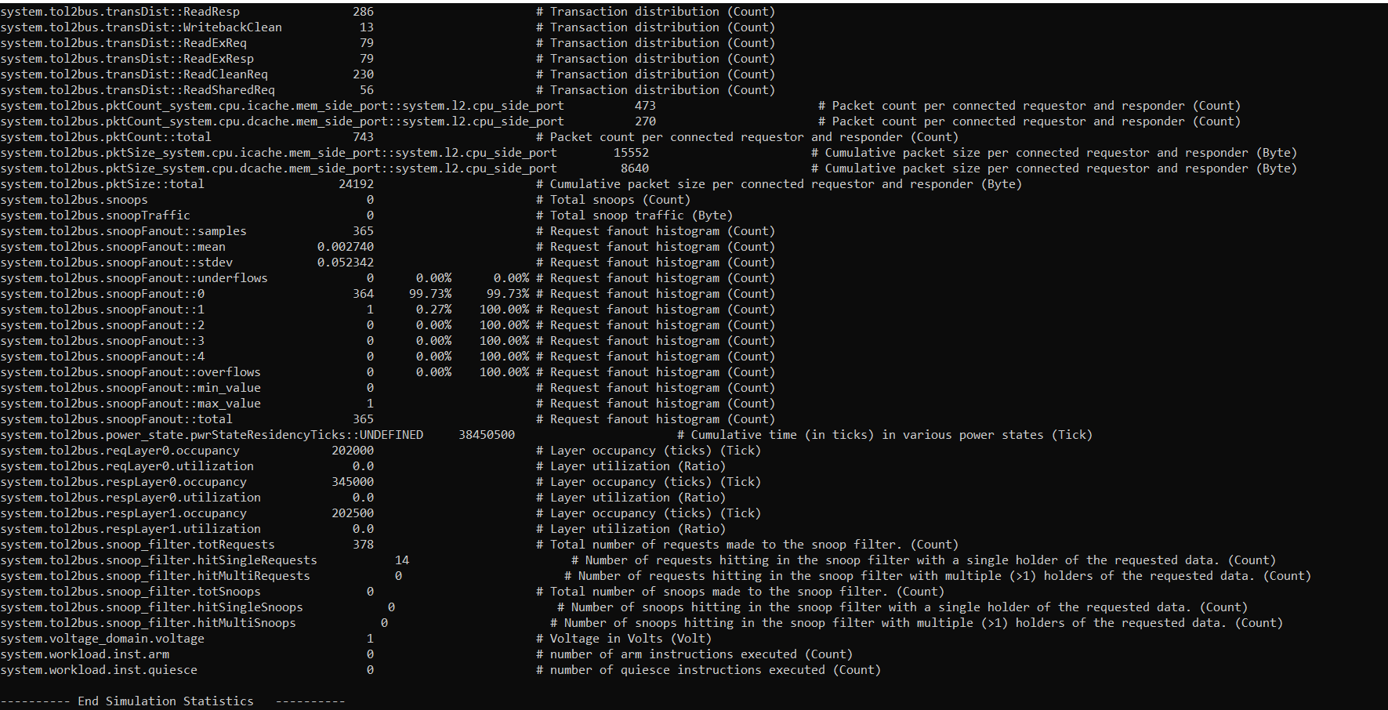

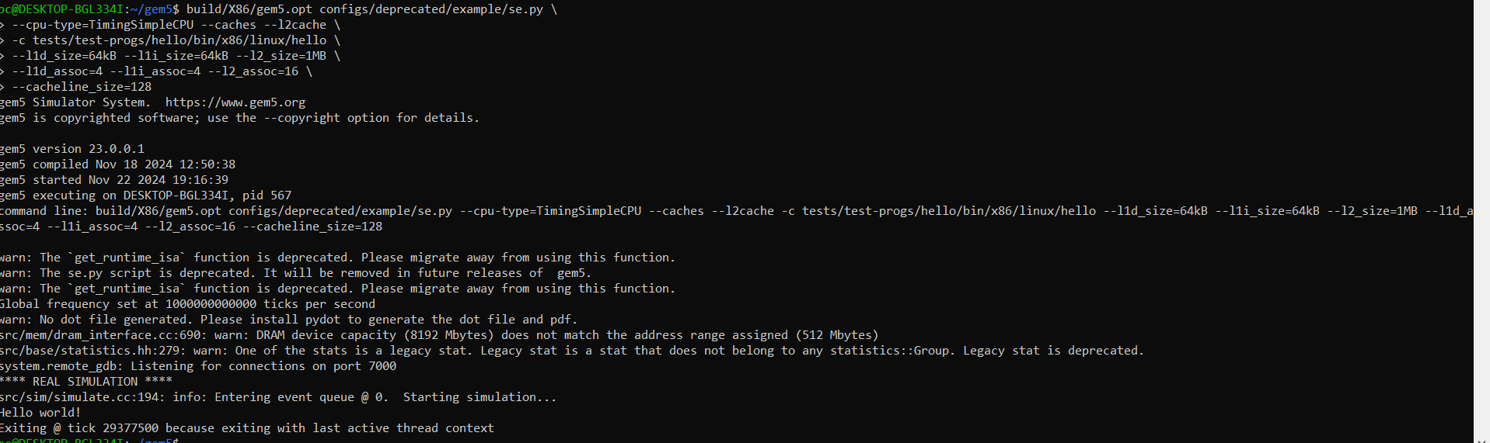

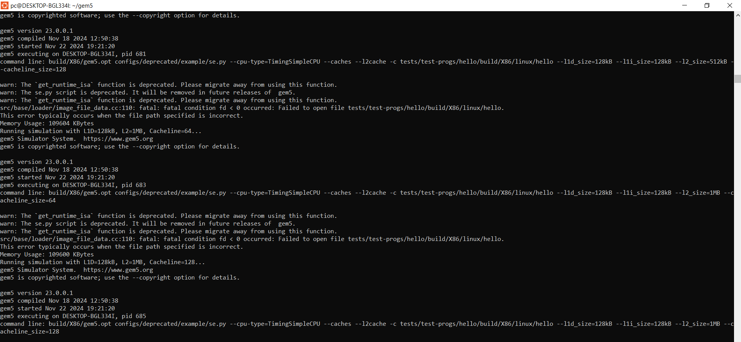

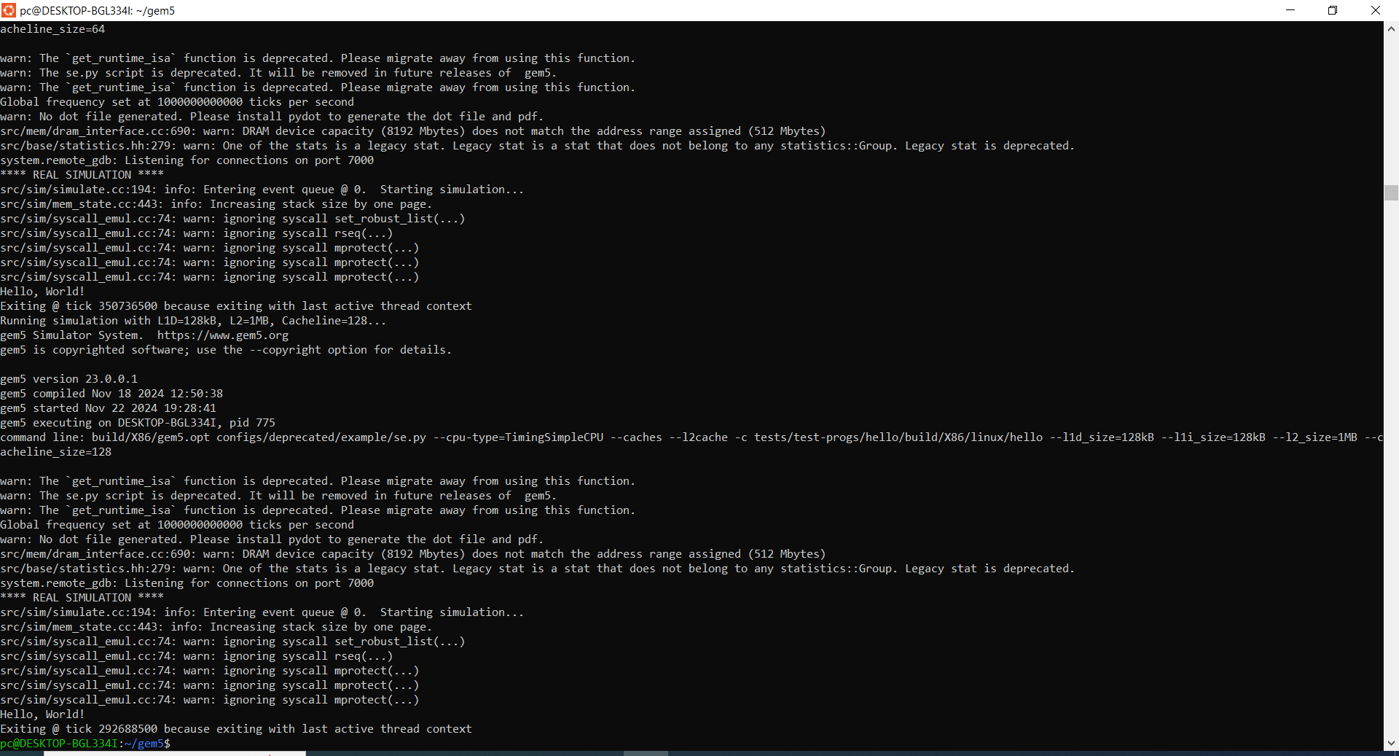

Variations in cache configurations in the gem5 simulations provide important new perspectives on performance trade-offs between many cache configurations. Important metrics like Cycles Per Instruction (CPI), Instructions Per Cycle (IPC), and simulation time (simTicks) were investigated across the tested setups.  
  
Generally increasing the L1 data cache (l1d_size) or L2 cache (l2_size) enhanced the CPI and IPC. L1D=32kB, L2=1MB, Cacheline=128. L2 cache of 1MB, for instance, lowered CPI from around 7.33 to 6.10. Reduced cache misses at higher levels improves memory access efficiency.  
  
Larger cacheline size (128 bytes) has shown improved simulation performance (simTicks and hostTickRate) and a little CPI decrease over 64-byte cachelines. For sequential memory accesses, larger blocks aid to lower cache misses, therefore enhancing general performance.  
  
Increasing the L1D cache size to 64kB somewhat enhanced IPC; the advantage was most evident when combined with bigger L2 caches. This implies a harmonic link between L1 and L2 sizes in clearing memory-intensive applications' constraints.  
  
Configurations with lower caches and cacheline sizes exhibited higher CPI (e.g., 7.33 with 256kB L2 cache and 64B cacheline), therefore suggesting inferior memory performance. By comparison, ideal setups such as L1D=64kB, L2=1MB, Cacheline=128 found a balance, therefore reducing CPI to 6.10 and raising IPC to 0.1639.  
  
These tests show, in the end, the need of matching cache configurations with workload needs to get best performance. Generally speaking, larger cache sizes and block sizes provide better results; yet declining returns may happen beyond certain thresholds.